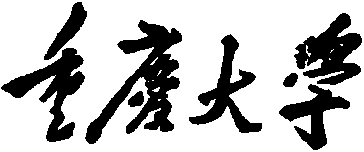 

**Personal Learning Portfolio**

**Course： English Academic Writing Teacher： Zhang Mei**

**Class： 002 Major： Computer Science**

**Name： Wen Hongbing Student Number： 20214590**

**Class Time： 2023.02-2023.07**

**Grade：**

|  |  |  |
| --- | --- | --- |
| **Self** | **Teaching Assistant** | **Teacher** |
| **9** |  |  |

**Comments：**

**Teacher (Signature)**

**Contents**

**Week 8**

1. **My learning**

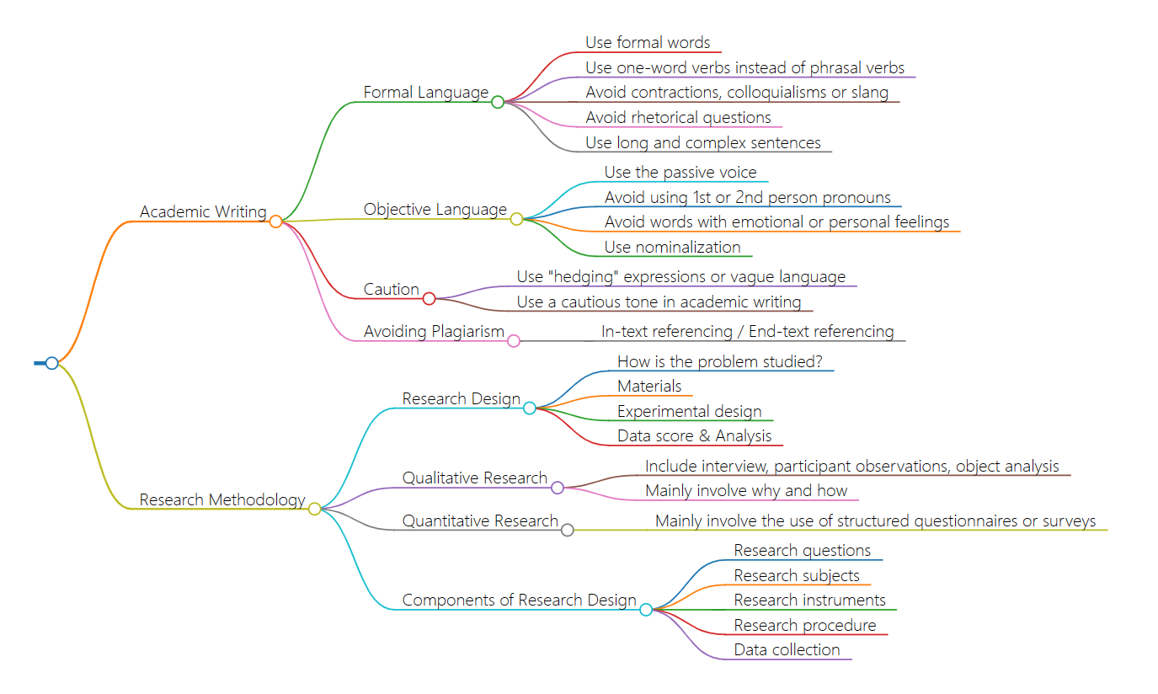

1. **Learning outcomes**

* Academic papers need to use formal language, avoiding slang, colloquialisms, and abbreviations.In future writing, I will follow the rules of academic writing, using formal language, including avoiding slang and colloquialisms, using a word verb, etc. This can make my copy writing more professional and more suitable for publication in professional settings.
* Use objective language, try to avoid first-person or second-person pronouns, use passive voice and nounization to maintain objectivity.In the future writing process, I will try to maintain objective language, use passive voice and nounization, and avoid using first- or second-person pronouns. This preserves the objectivity of the article and increases persuasiveness.
* In academic papers, expressions should be used carefully, using "wording" expressions, and trying to avoid using too many subjective expressions.In my future writing, I will use "wording" to strengthen my expression, using words such as "probably", "seeming", "maybe" and so on to express my opinion, leaving room for myself and expressing my respect.
* Academic papers should pay attention to literature citation and try to avoid plagiarism.In my future writing, I will pay attention to literature citation to avoid plagiarism and infringement. I will reasonably quote the research of other scholars to make my articles more convincing and in line with academic norms.

1. **My behavior and attitude**

* Good concentration and endurance, showing high concentration and endurance in the learning process, able to concentrate on completing tasks.
* Not active in the classroom.

1. **Improvement**

Outstanding students will actively participate in class discussions and activities, express their own opinions and questions, and should be more active in class activities and questions

**Week 9**

1. **My learning**

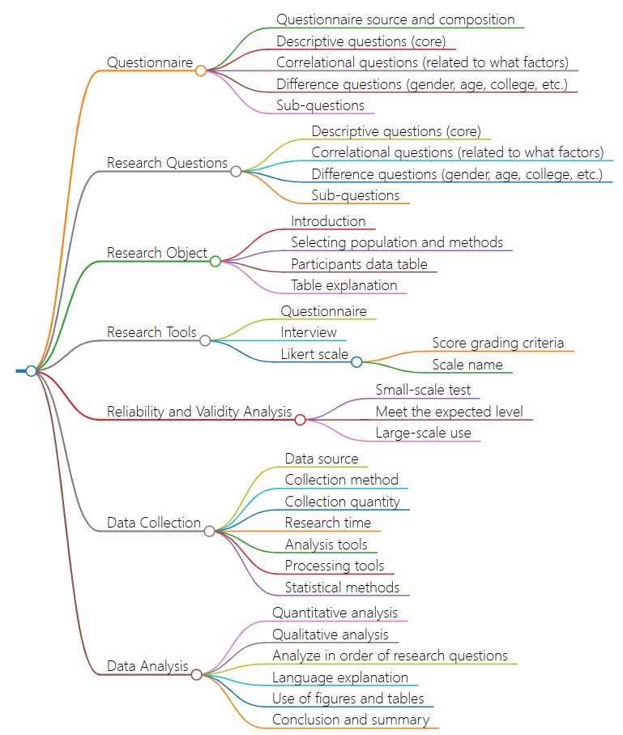

1. **Learning outcomes**

* Master the basic elements and processes of data collection and analysis, and improve the efficiency and accuracy of data collection and analysis; Better formulate questionnaires and research questions in future scientific research work;
* Understand the influence of data source, collection method, quantity and time, which has great reference for future research design; Pay more attention to scientific and practical aspects of the selection, data collection and processing of research objects;
* Know to explain the research results in scientific and objective language, and use charts to visually represent them. Use scientific statistical methods and data analysis tools when conducting research to enhance the reliability and practicality of research results.

1. **My behavior and attitude**

Compared with last week, my class attitude and class quality have been improved. I have slackened in extracurricular learning, so I should complete extracurricular learning quantitatively.

**4．Improvement**

Hope to continue to work hard next week, not slack off in extracurricular studies, study extracurricular knowledge regularly and quantitatively, and maintain the level of English learning.

**Week 10**

1. **My learning**

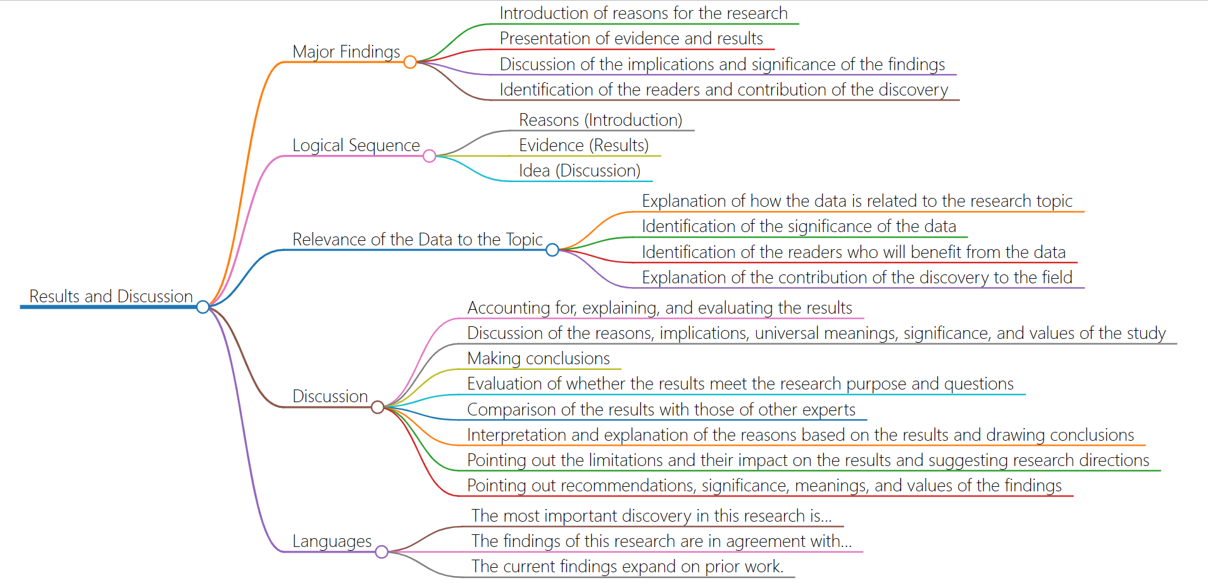

1. **Learning outcomes**

* Understand the logical sequence of research results and discussion.When writing a paper, you can organize your findings and discussions in a logical order.
* Understand the relationship between data and the research topic as well as the significance and contribution of data.When analyzing data, it is necessary to consider the relationship between the data and the research topic as well as the significance and contribution of the data.
* The content and structure of the discussion were studied, including interpretation, evaluation and comparison of the results, as well as answers and suggestions for research objectives and questions.When discussing the findings, the results need to be interpreted, evaluated and compared, and recommendations and directions for future research need to be made.
* I learned the way of language expression in academic papers.When writing academic papers, we can learn from some common language expressions to improve the expression ability and quality of papers.

1. **My behavior and attitude**

My learning attitude this week was a little loose. I didn't think about the presentation of one-minute content seriously, so that others could quickly understand my introduction

**4．Improvement**

I should have thought more carefully about how to present my introduction better, so that others could understand my content more quickly and suggest improvements. At the same time, it is also necessary to adopt different presentation methods at different time, so as to better adapt to different occasions and audiences